**PCA List**

The PCA List is a public list that is pulled and published monthly. The completed PDF goes to primary website maintenance liaison, who is currently Angela Salerno, for posting to website. If requested to forward to Karen Copely, the Department’s website manager, also copy Unit Manager

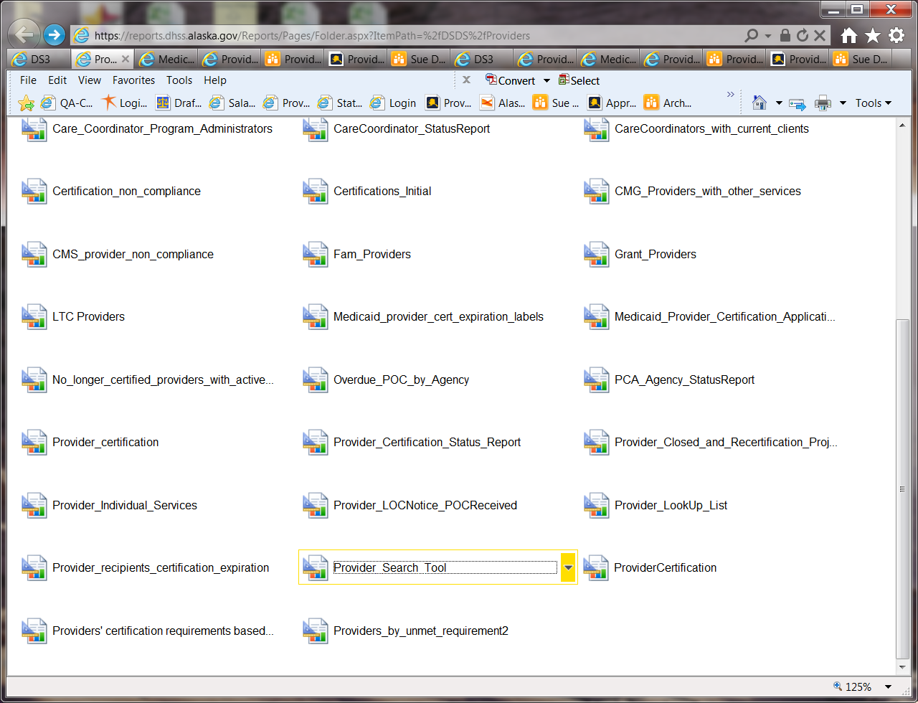

* Reports Manager > Provider_Search_Tool report

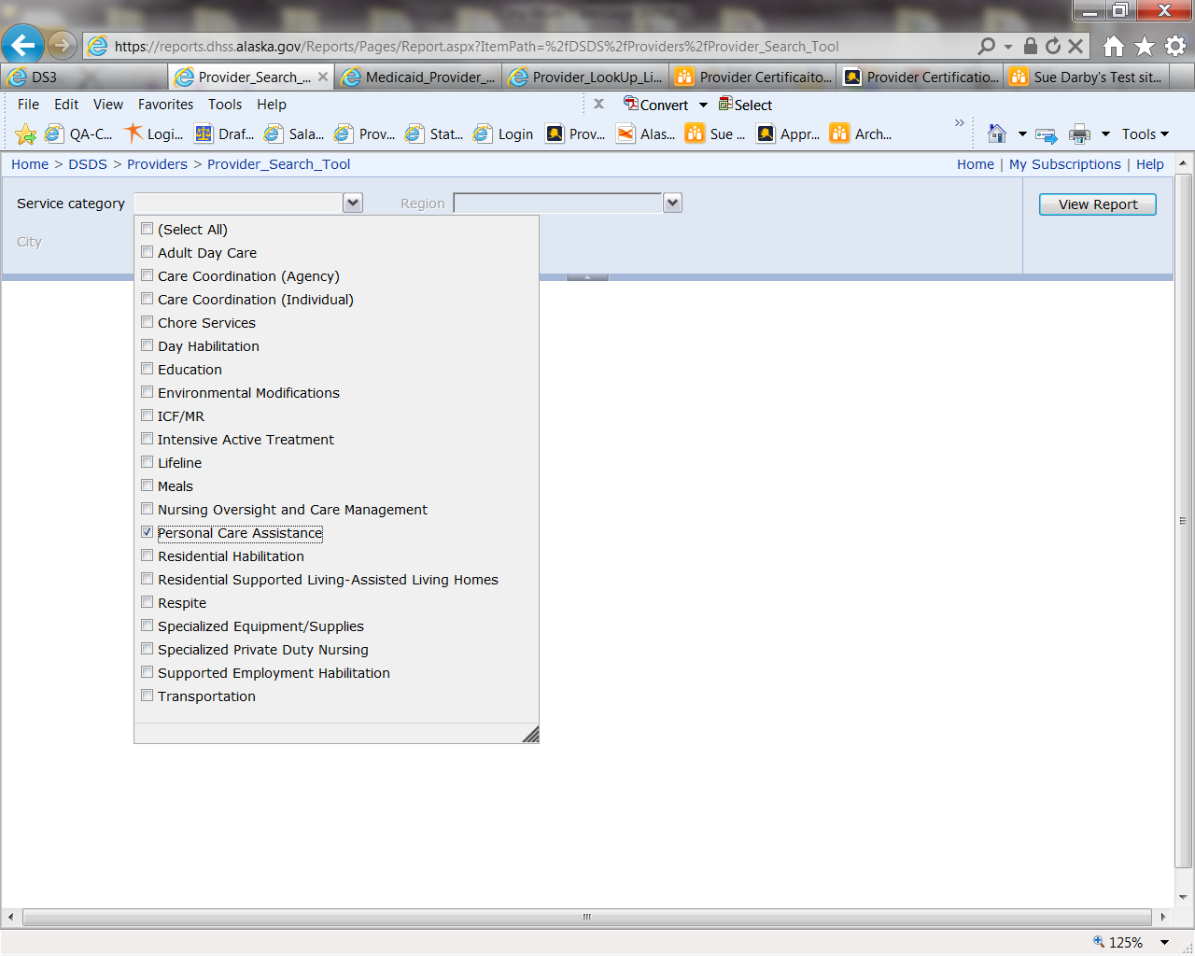

* Service Category →Personal Care Assistance

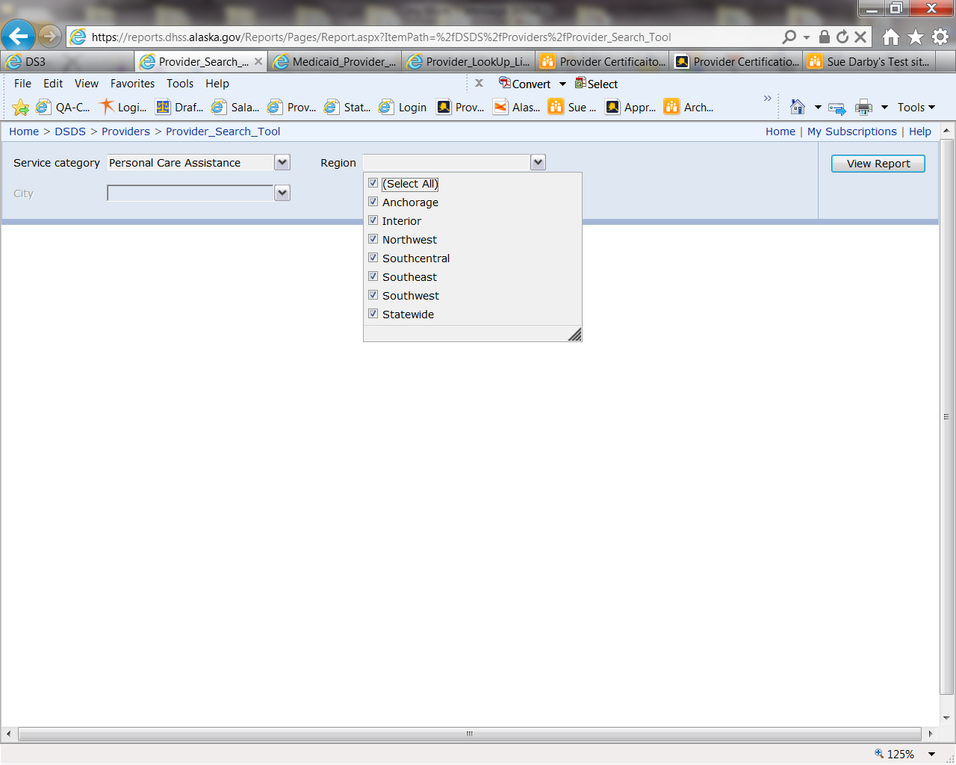

* Region → All

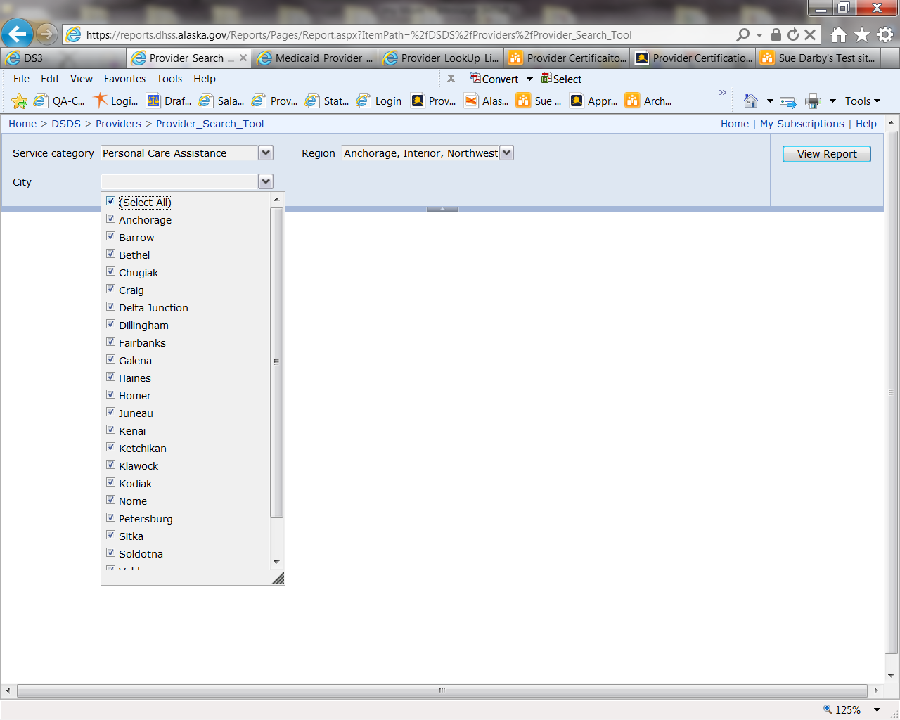

* City → All

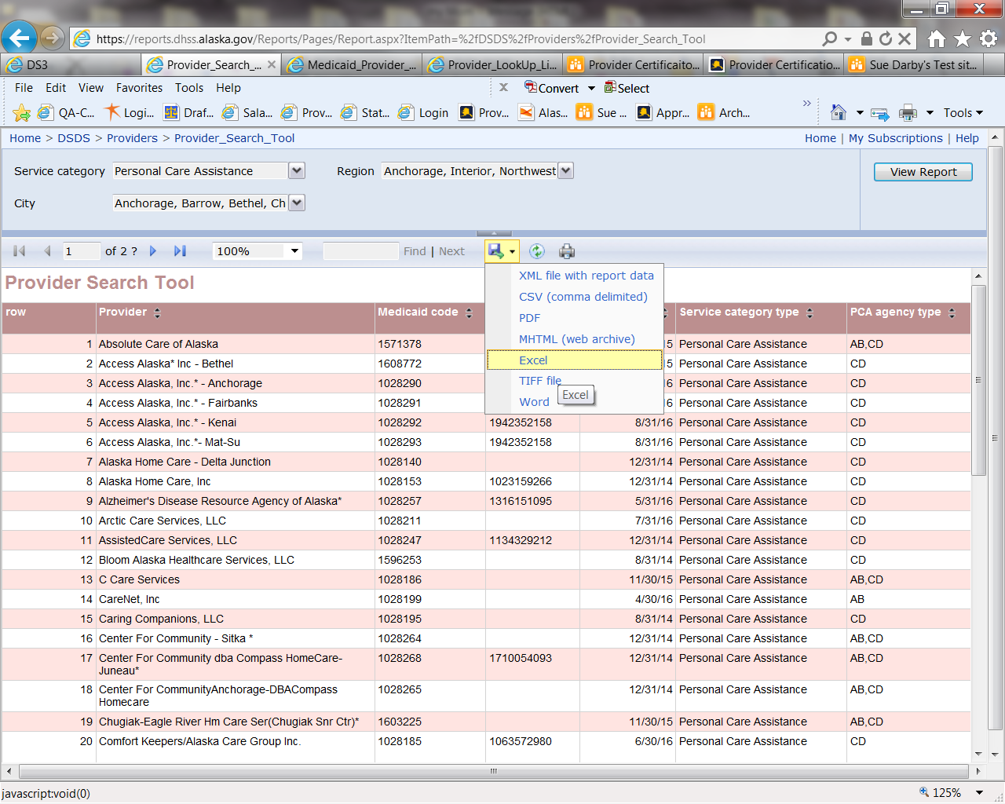

* Report is displayed
* Export to Excel

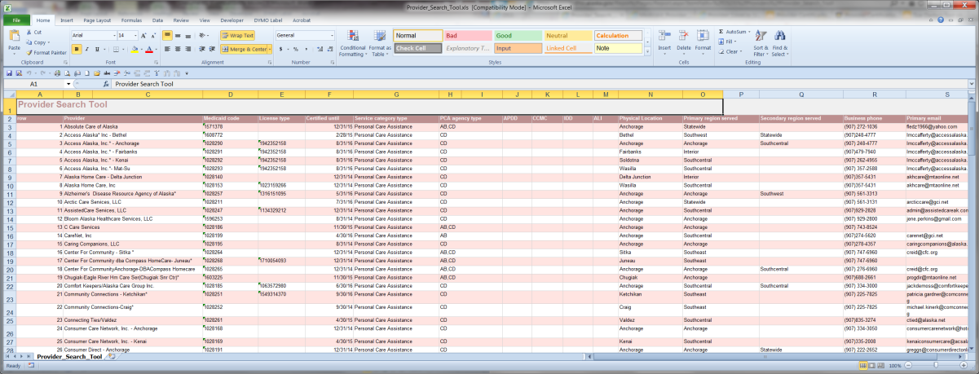

* Generated Report

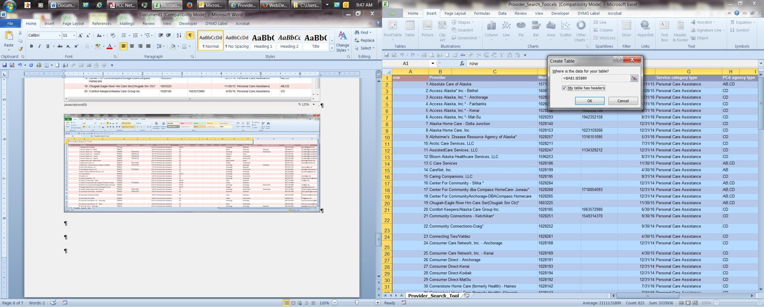

* Convert to Table
* While the sheet is highlighted apply a No Color Fill to change the color to blue

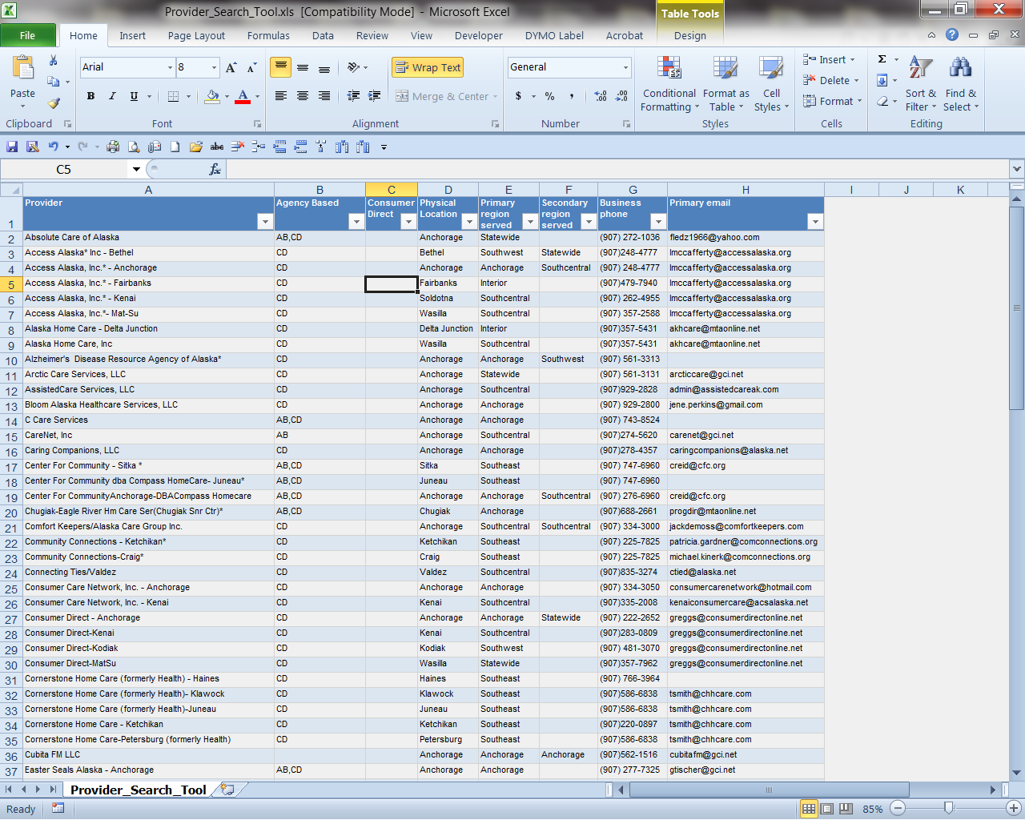

* Delete extra Columns
* Re-label APDD to Consumer Direct and PCA Agency Type to Agency Based

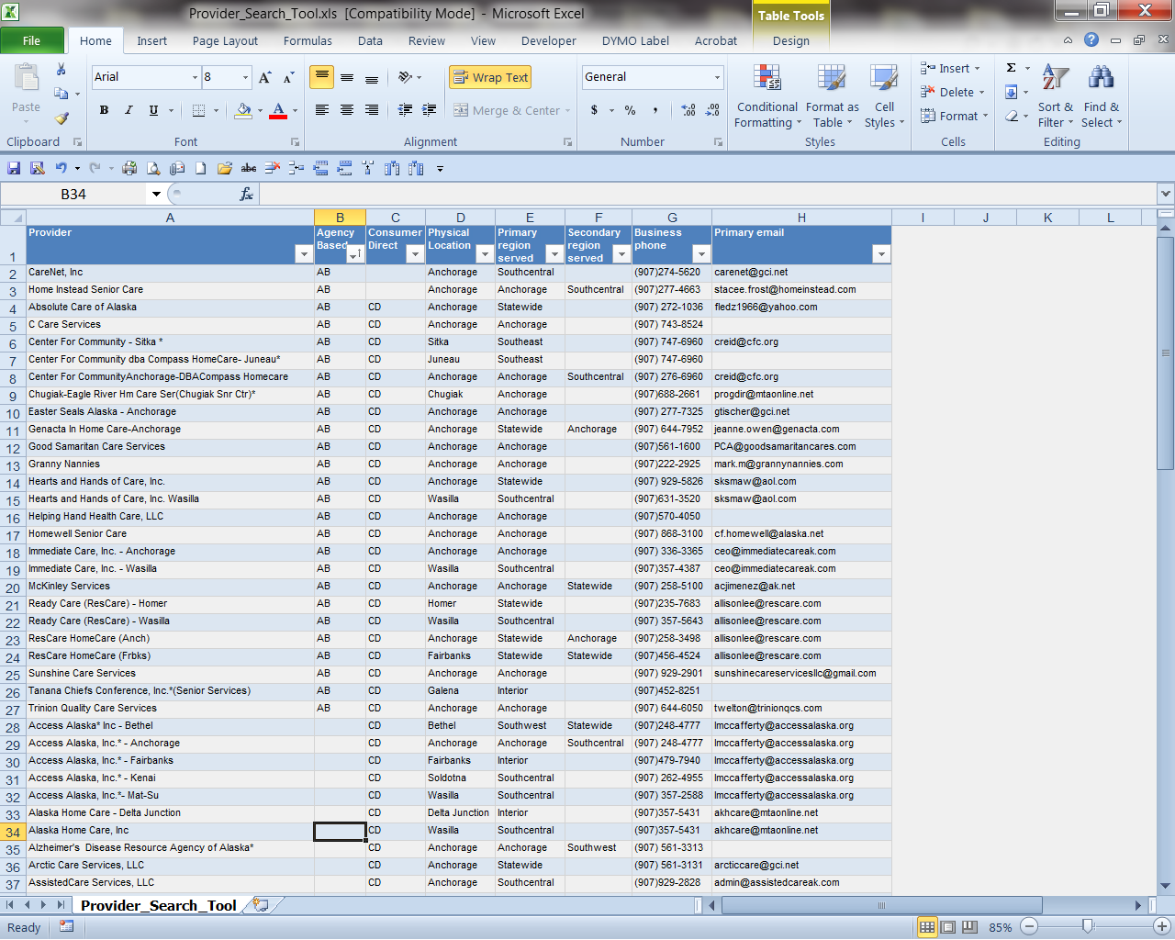

* Sort by Agency Based A-Z
* Separate out the Agency Based vs Consumer Directed into the second column
* Re-alphabatize by Provider A-Z

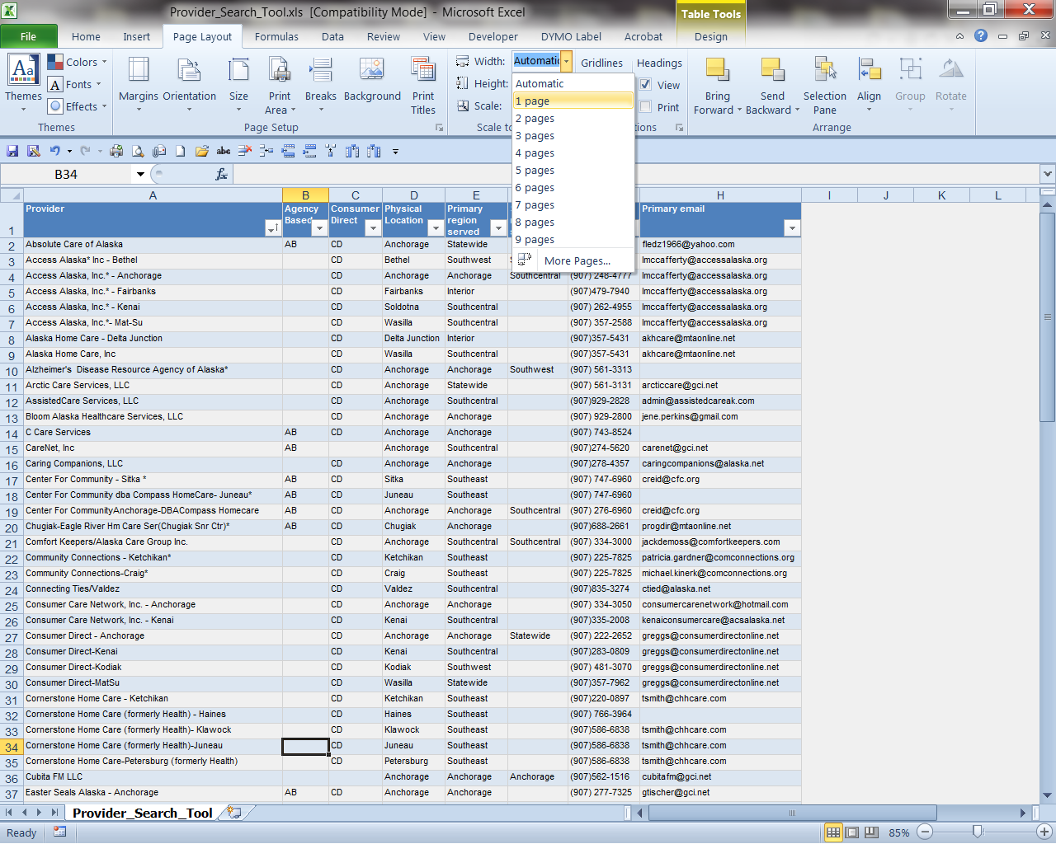

* Go to Page Layout and change Width to 1 Page

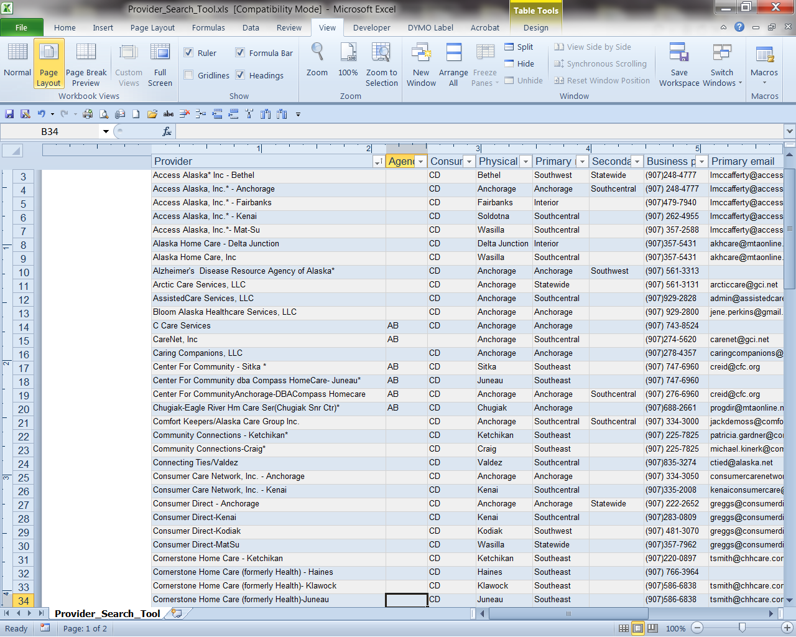

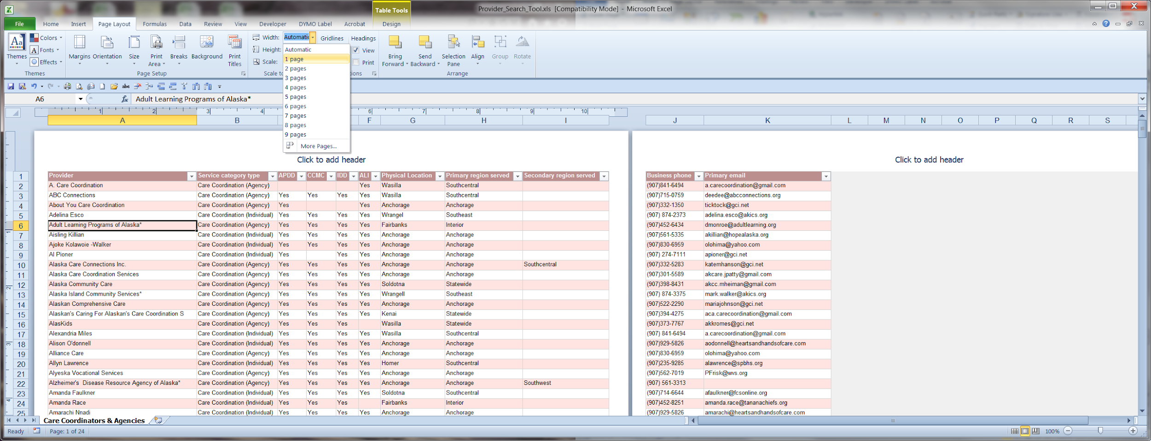

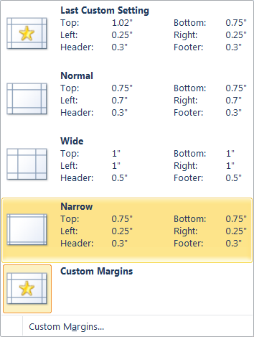

* Go to Page Layout →Orientation → Landscape then Margins→Narrow

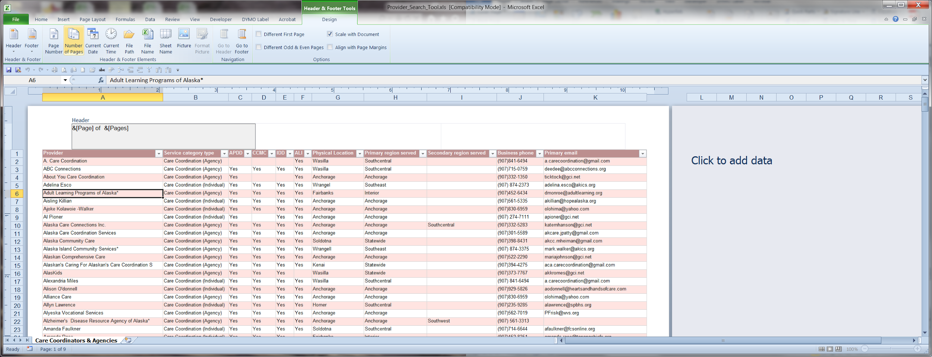

* Add Page Number (type )of then Number of Pages to the left header

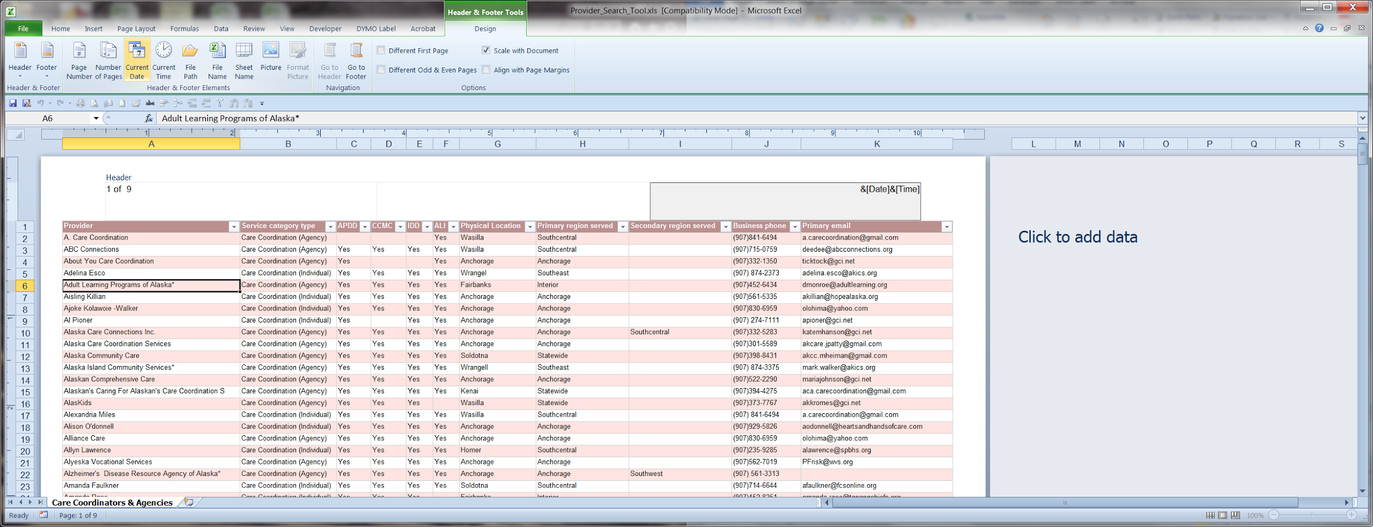

* Add Current Date and Current Time to the right header

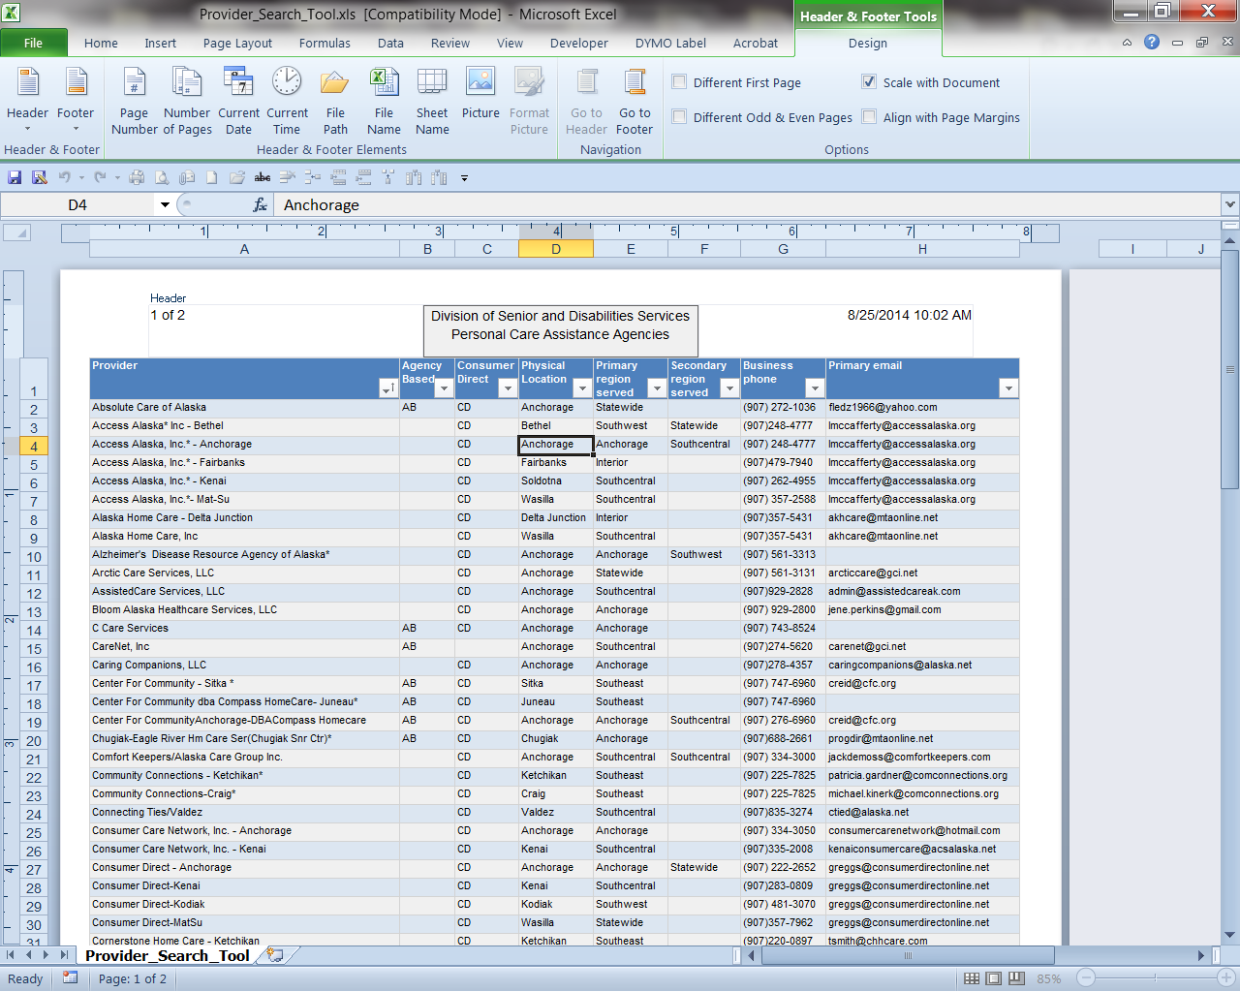

In the center section add:

Division of Senior and Disabilities Services

Personal Care Assistance Agencies

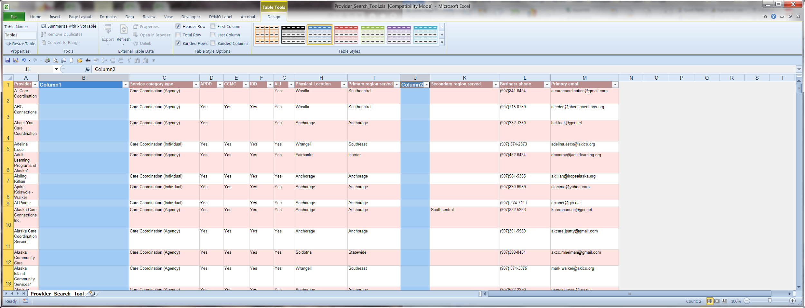 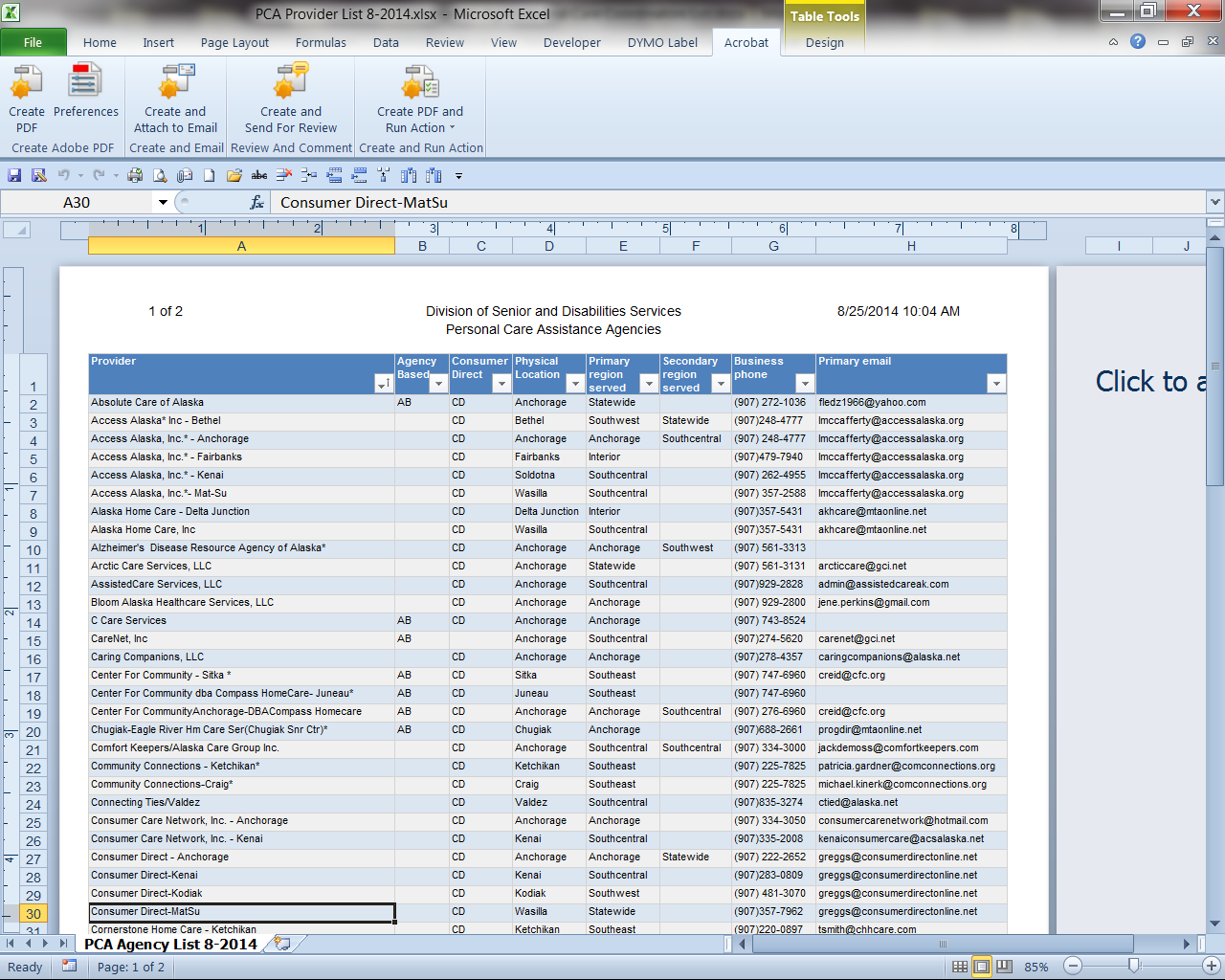

* Right click on the sheet name and Rename it to PCA Agency List 8-2014 (or current month & year)

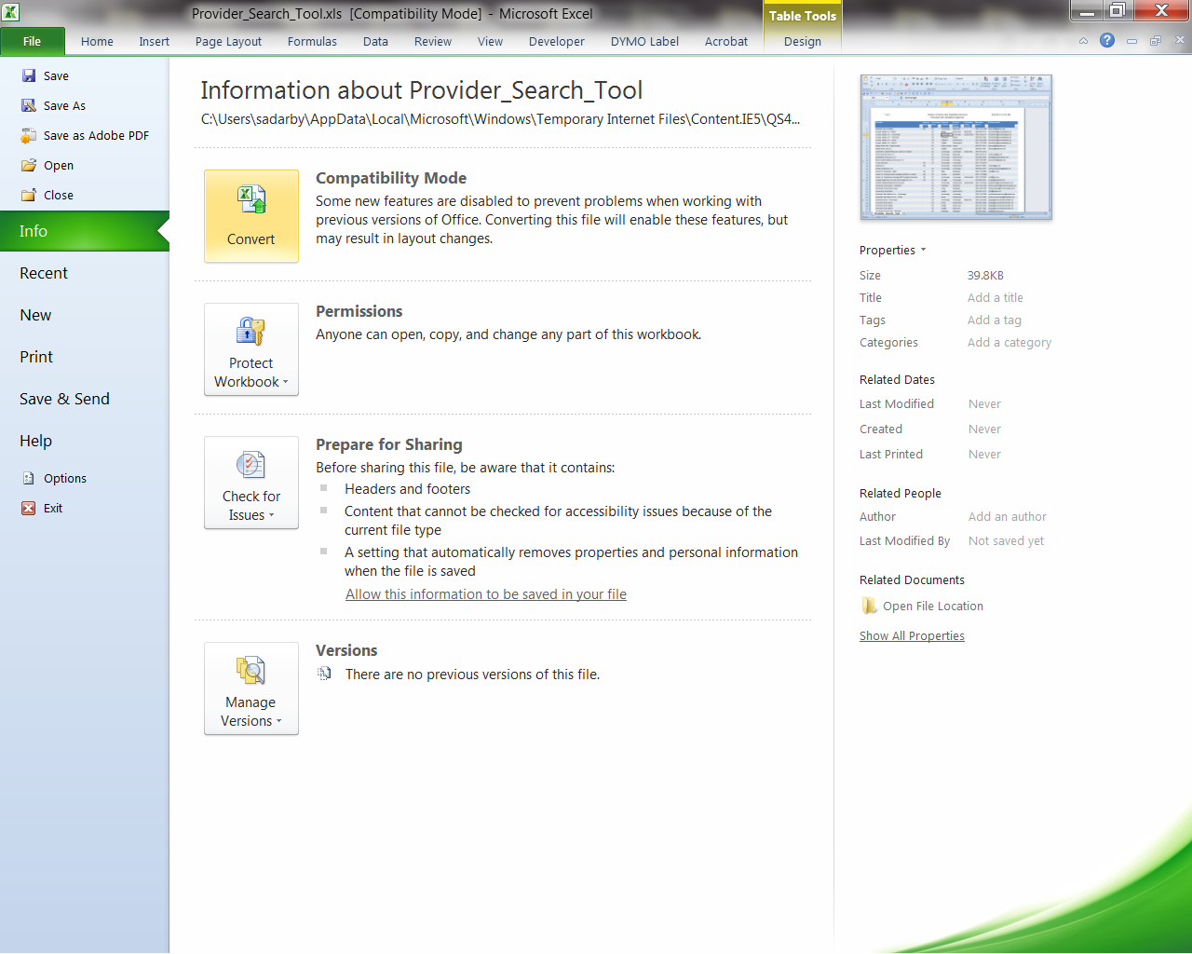



* Go to File → Convert and click Yes

This ensures that the tweaks such as the table used is saved and makes the file format a XLSX which saves in a smaller file.

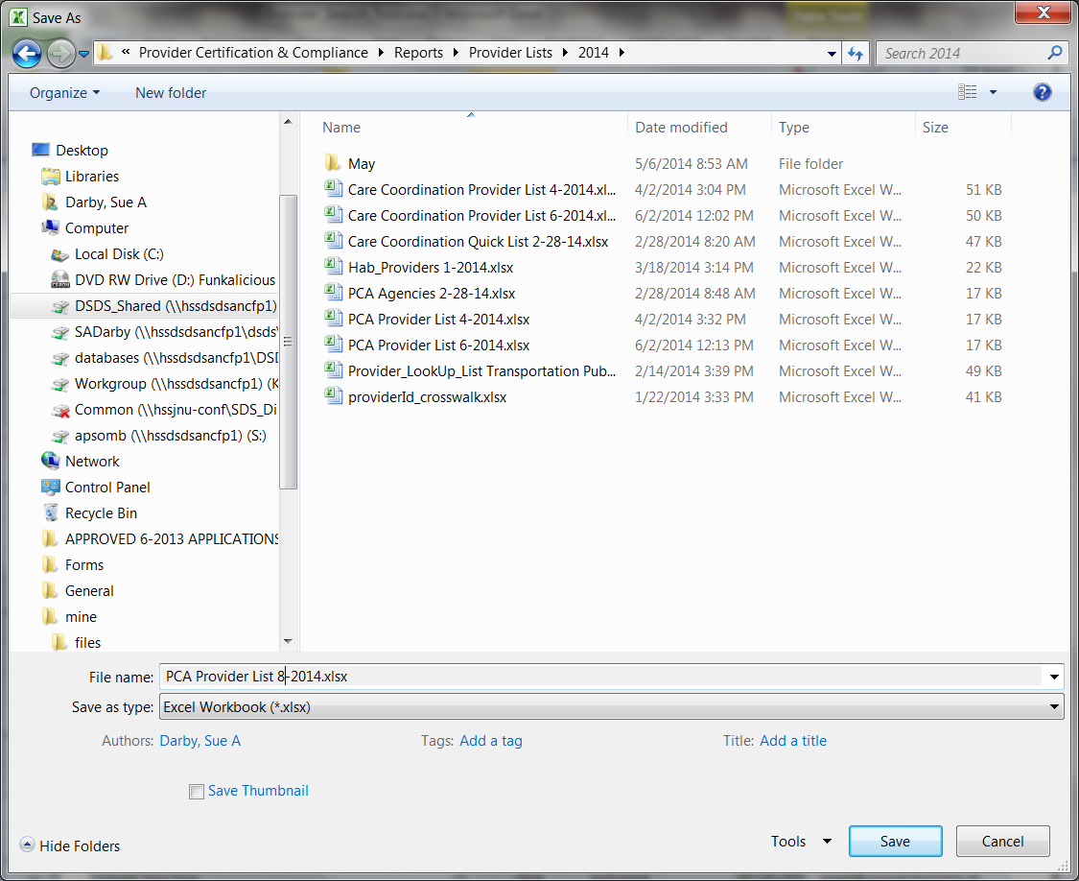

* Save in G:/Provider Certification & Compliance →Reports→Provider Lists → 2014
* Save As PCA Provider List 8-2014.xlsx

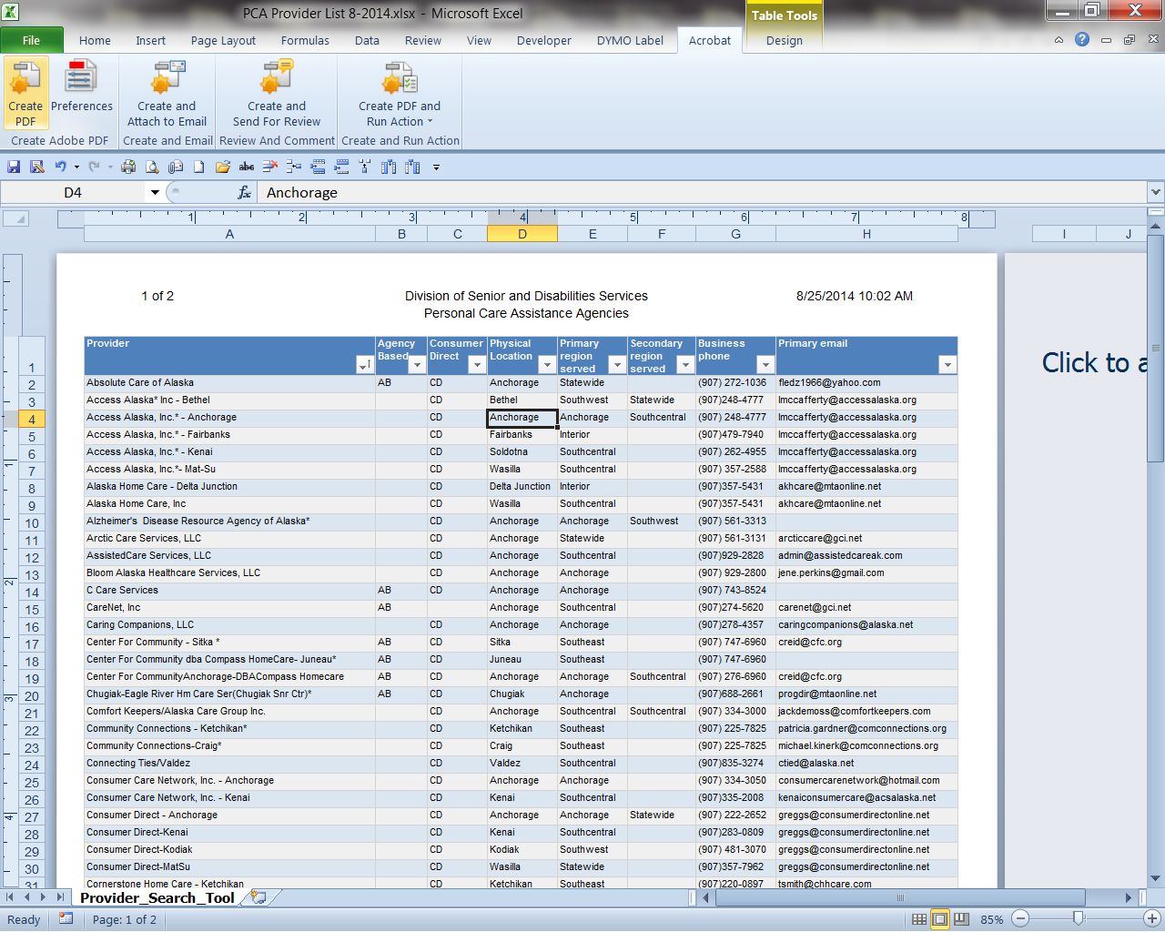

* Go to Acrobat → Create PDF

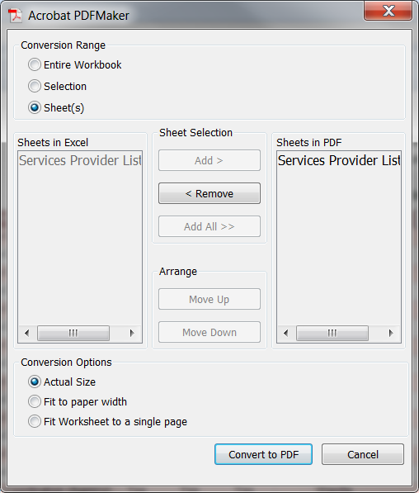

* Click Convert to PDF

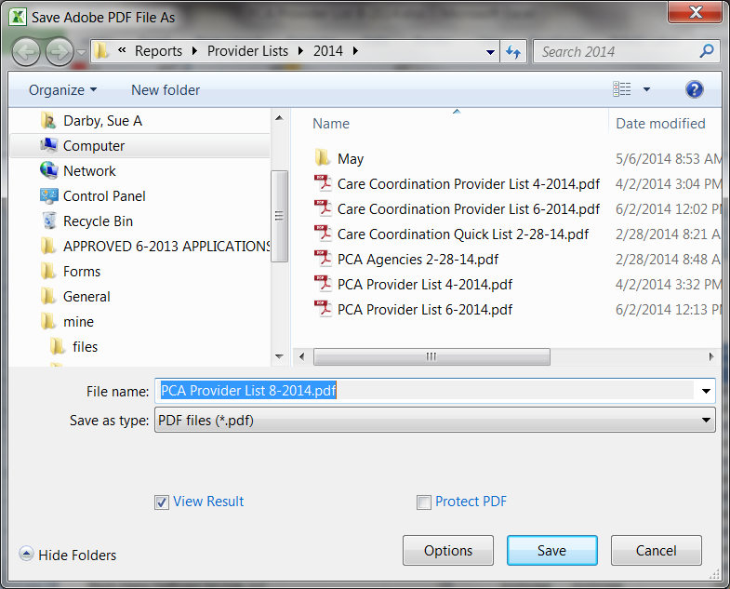

* When Prompted SAVE!
* PCA Agency List and Current Month-Year
* Word & Adobe will convert the file and open it in Adobe when completed

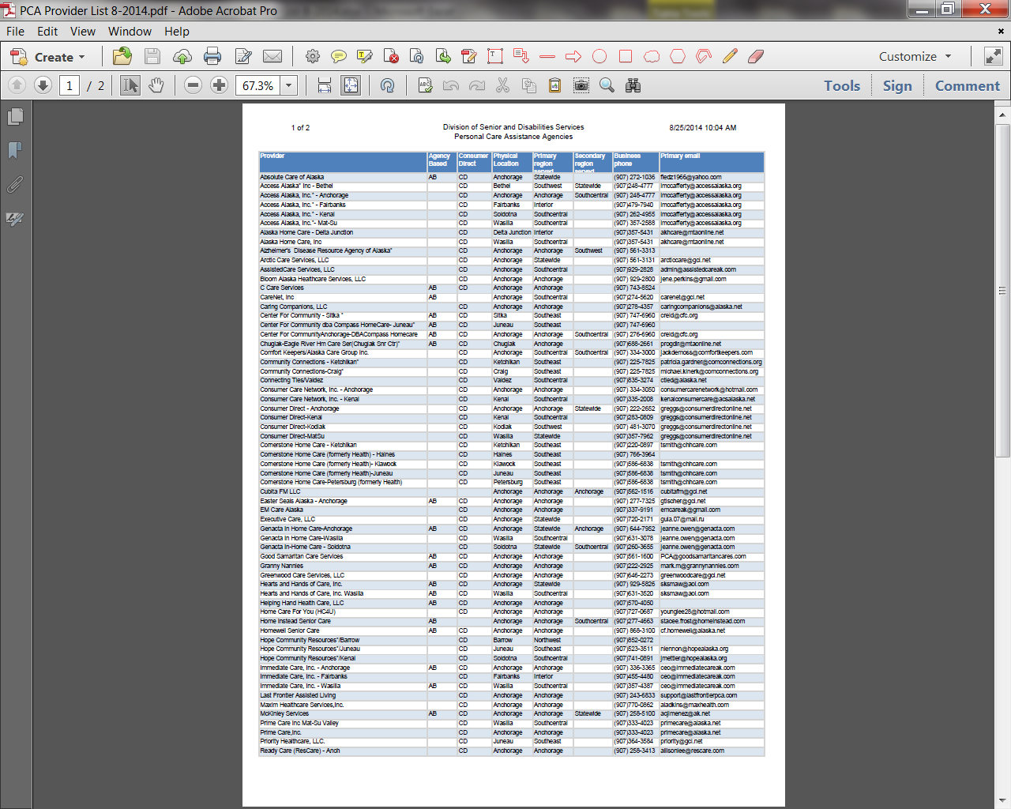

* Completed file for posting